Lecture 3 (Ch 23.6-7)



Electric field is Force per Unit of Charge [ newton / coulomb]

$\frac{Force}{q_{test}}$, where qtest is our test charge

So, in each point in space there is a vector $\vec{E}$: (the electric field in that point)

How to visualize the electric field?

* we draw **electric field lines**



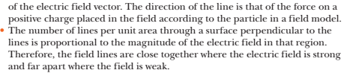

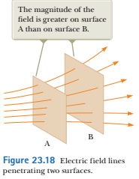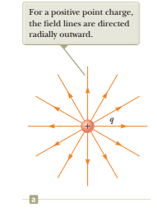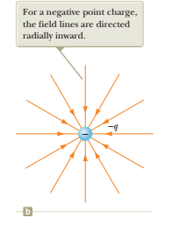

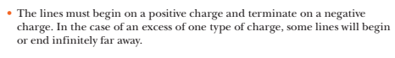



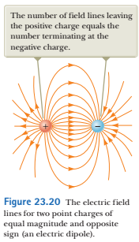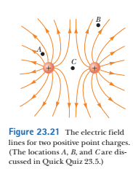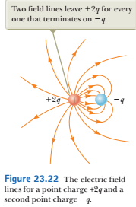

<https://www.youtube.com/watch?v=63FnT0W-Hxc>



a particle with mass m, charge q in the electric field E:

the exerted electric force is:

$\vec{F}=q∙\vec{E}=m∙\vec{a}$, a - acceleration

Hence, 

Problems:

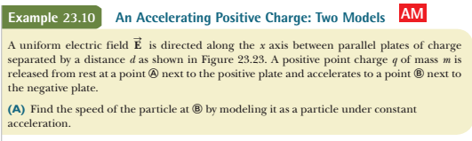

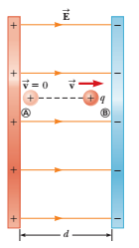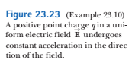

acceleration a = q*E / m

velocity at B is: v = a*t

t is time interval to reach point B

distance d for accelerated motion is given by: d = at2/2 = (at)2/(2a)

Check out the expression for v above

Hence, d = v2/2a , and v2 = 2*a*d = 2dqE/m



$$v= \sqrt{2dqE/m}$$

work done by the constant force: F*d

it is equal to the kinetic energy of the particle at the point B.

The initial kinetic energy is zero (at point A)

Hence, qEd = m v2 /

from here we get the velocity : $$v= \sqrt{2dqE/m}$$

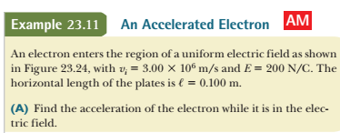

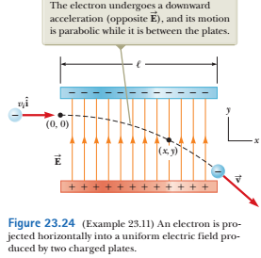x-axis: vx = constant

y-axis: force F = eE

hence, the acceleration has only vertical component and is equal to:

$a_{y}=\frac{F}{m}=eE/m$

